Introduction:

PartTimer is a web-based application built using the MERN stack (MongoDB, Express.js, React.js, Node.js).
It bridges the gap between individuals seeking short-term, flexible work and employers offering temporary or skill-specific opportunities.
The platform focuses exclusively on short-duration and part-time jobs, which can range from a few hours to a few months.

It empowers:
- Students looking to gain part-time experience.
- Freelancers seeking quick and skill-based projects.
- Employers in need of temporary workforce or specialized assistance.
PartTimer provides a simple, reliable, and efficient environment for connecting job seekers and employers, ensuring transparency, trust, and real-time communication between both parties.

1.1 Functionalities / Modules:

Functionalities
- Secure user registration and login with roles- Job Seeker, Employer, Admin
- Profile management- including personal info, skills, experience, and availability
- Job posting system- employers can specify type, location, duration, and payment
- Job search and filtering- search by skill, duration, pay, or location
- Application tracking- job seekers can view status (Applied / Accepted / Rejected / Completed)
- Real-time notifications- for updates (browser + email)
- Messaging system- for direct communication between seekers and employers
- Ratings & reviews- for credibility and accountability
- Admin panel - moderation, reports, and analytics

Mobile-friendly responsive UI

Module Description
- Authentication Signup, login, logout, password reset, email verification
- User Profiles Manage info for both seekers and employers
- Job Management Post, edit, delete, and view available jobs
- Job Search Filter by location, duration, skills, and budget
- Application Tracker Track job applications, manage statuses
- Chat & Notification Real-time messaging and alerts (ON HOLD)
- Review System Give feedback and ratings after job completion
- Admin Dashboard Manage users, jobs, and monitor platform stats

Users: (Roll and how they interact with system)
- Job Seekers: Register, build profile, search and apply for jobs, communicate with employers, and give feedback
- Employers: Register, post and manage jobs, view applicants, communicate, and rate candidates
- Admin: Oversee users and jobs, moderate content, and analyse platform usage and performance

Number of User Interfaces:
- Landing / Home Page
- Registration Page (separate for Job Seeker & Employer)
- Login Page
- Job Seeker Dashboard
- Employer Dashboard
- Admin Dashboard
- Profile Pages (Seeker / Employer)
- Job Listing & Job Details Page
- Application Tracker
- Messaging Interface (ON HOLD)
- Notifications Centre
- Reviews & Ratings Page (ON HOLD)
- Settings Page (password, preferences)

1.2 Existing System

The existing system refers to the current method or approach that was in use before the development of the proposed project. This system is generally manual or semi-automated and has several limitations that affect efficiency, accuracy, and user experience.
Description of the Existing System
- The existing system relies heavily on manual processes for managing tasks and information.
- Data is often stored in files or basic spreadsheets, making retrieval and updates time-consuming.
- There is no centralized platform to manage all operations in one place.
- Users must perform repetitive tasks manually, which increases workload and chances of error.
- Communication and coordination between different users or modules are inefficient.
Technologies Used (if any)
- Basic tools such as:
  - Paper records or registers
  - MS Excel / simple databases
  - Standalone applications without integration
- No use of modern web technologies or real-time data handling.
Limitations of the Existing System
- Time-Consuming
  - Manual data entry and processing require more time.
  - Searching and updating records is slow.
- Error-Prone
  - High possibility of human errors during data entry and calculations.
  - Lack of validation mechanisms.
- Data Redundancy
  - Same data may be stored multiple times in different files.
  - Leads to inconsistency and confusion.
- Poor Security
  - Data is not well protected.
  - Unauthorized access or data loss is possible.

- Limited Scalability
  - Difficult to handle an increasing number of users or records.
  - System performance degrades as data grows.

- Lack of Automation
  - No automatic report generation or notifications.
  - Manual effort required for routine operations.
Overall Drawbacks
- Inefficient management
- Low reliability
- Difficult maintenance
- Not user-friendly
Because of these drawbacks, there is a strong need for a new, automated, and efficient system, which is addressed by the proposed system.

1.3 Need and Scope of the System

The need and scope of the system explains why the proposed system is required and defines the boundaries within which the system will operate. It highlights the problems of the existing system and how the new system addresses them effectively.

Need of the System
The development of this system is necessary due to the following reasons:
- Automation of Manual Processes
  - The existing system involves manual or semi-automated operations.
  - Automation reduces human effort and improves overall efficiency.
- Improved Accuracy and Reliability
  - Manual data handling leads to frequent errors.
  - The proposed system ensures accurate data processing with proper validation.
- Centralized Data Management
  - All information is stored in a single, centralized database.
  - Easy access, update, and retrieval of data.
- Time Efficiency
  - Reduces time required for performing routine tasks.
  - Faster processing and quick access to information.
- Enhanced Security
  - User authentication and authorization mechanisms protect sensitive data.
  - Reduces the risk of data loss and unauthorized access.
- Better User Experience
  - User-friendly interface for easy interaction.
  - Reduces complexity and learning time.
- Scalability
  - Capable of handling increased users and data in the future.
  - Supports system growth without major changes.

Scope of the System
The scope defines what the system will cover and what functionalities it will provide.
- User Management
  - User registration and login.
  - Role-based access control (Admin/User).
- Data Management
  - Create, read, update, and delete (CRUD) operations.
  - Secure storage and retrieval of information.
- Process Automation
  - Automated workflows to reduce manual intervention.
  - System-generated reports and outputs.
- Monitoring and Control
  - Real-time tracking of activities.
  - Administrative control over system operations.
- Reporting
  - Generation of reports for analysis and decision-making.
  - Export options if required.
- System Maintenance
  - Easy updates and maintenance.
  - Error handling and logging mechanisms.

Out of Scope
- Hardware-level maintenance
- Third-party system integrations (unless specified)
- Offline functionality (system requires internet access)

Conclusion
The proposed system is designed to overcome the limitations of the existing system by providing a secure, efficient, scalable, and user-friendly solution. Its scope ensures that all essential functionalities are covered while allowing future enhancements.

2. Analysis and Design

1 Existing System Analysis
In the existing system, part-time job seekers rely on offline sources such as notice boards, agents, or personal references. This approach has several drawbacks: - Lack of centralized information - High chances of fraud or fake job postings - Time-consuming manual processes - Limited reach for employers

2 Proposed System
The proposed Part-Time Job Portal overcomes the limitations of the existing system by providing: - Centralized job database - Online job application facility - Easy accessibility through web browsers - Secure and structured data storage

3 System Requirements

Hardware Requirements
- Computer/Laptop
- Minimum 4 GB RAM
- Internet connection

Software Requirements
- Operating System: Windows / Linux
- Frontend: HTML, CSS, JavaScript, React
- Backend: Node.js
- Database: MongoDB / MySQL
- Browser: Chrome, Firefox

4 System Architecture
The system follows a three-tier architecture: 1. Presentation Layer (Frontend) 2. Application Layer (Backend) 3. Data Layer (Database)

Entity Relationship Diagram (ERD)

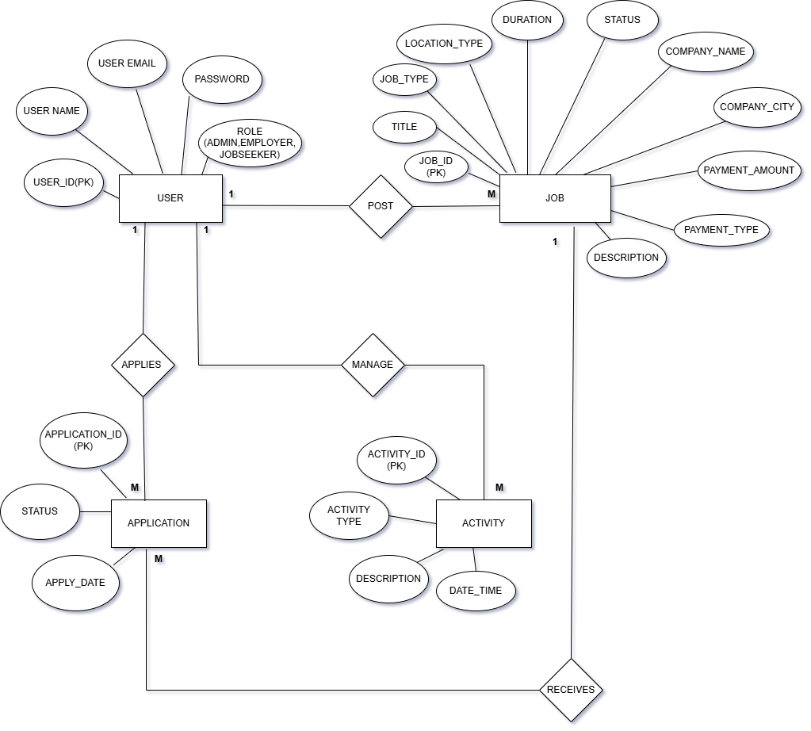

2.2 Use Case Diagram
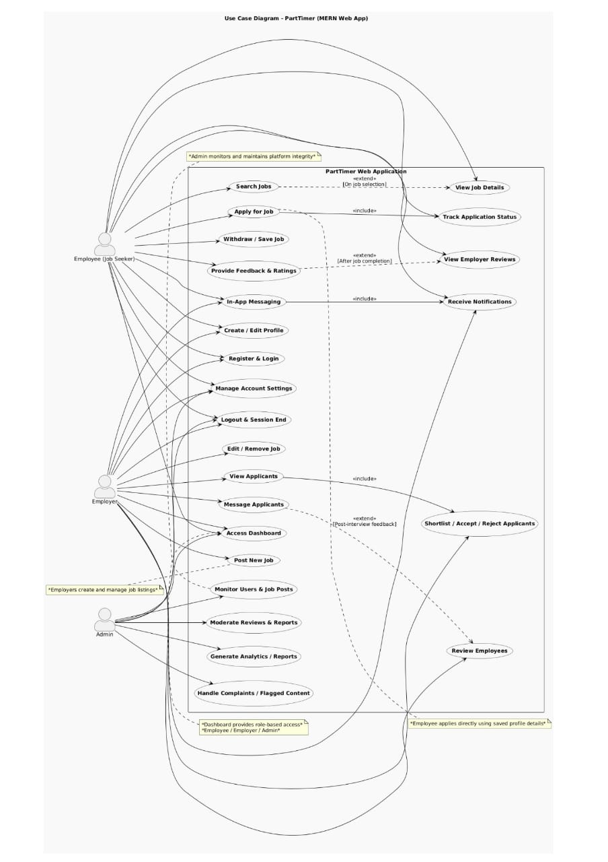

  - Table Structure / Data Dictionary

1)User Collection
Field | Type | Constraints / Description
_id | ObjectId | Primary Key, auto-generated by MongoDB
name | String | Required, full name of the user
email | String | Required, unique email ID
password | String | Required, stored in encrypted format
role | String | Required, Enum: admin / employer / jobseeker
Profile | Object | Embedded profile data
ProfilePhotoPath | String | Local image path
ResumePdfPath | String | Resume PDF path
moderation | Object | Warn / lock info
createdAt | Date | Auto-generated when user registers
updatedAt | Date | Auto-updated on profile modification

2) Job Collection
Field | Type | What You Should Write (Instead of Optional)
_id | ObjectId | Primary Key
title | String | Optional, job title provided by employer
jobType | String | Optional, defines job nature (Full-time / Part-time / Internship)
locationType | String | Optional, indicates Remote / Onsite / Hybrid
duration | String | Optional, applicable mainly for internships or contracts
status | String | Default: Active, updated to Closed when job expires
company_name | String | Required, name of the hiring company
company_industry | String | Optional, used for job categorization
company_city | String | Optional, used for location-based search
company_state | String | Optional, geographical information
payment_amount | String | Optional, salary or stipend amount
payment_type | String | Optional, Monthly / Hourly / Stipend
description | String | Optional, detailed job description
responsibilities | Array | Optional, list of job responsibilities
requirements | Array | Optional, eligibility and qualifications
skills | Array | Optional, required skills for the job
applicationDetails_openings | Number | Optional, number of vacancies
applicationDetails_lastDate | String | Optional, last date to apply
employerId | ObjectId | Required, reference to employer user
createdAt | Date | Auto-generated when job is posted
updatedAt | Date | Auto-updated when job details change

3) Application Collection
Field | Type | Description
_id | ObjectId | Primary Key
job | ObjectId | Required, reference to applied job
jobSeeker | ObjectId | Required, reference to applicant
status | String | Default: Applied, updated by employer
statusHistory | Array | Maintains record of status changes
createdAt | Date | Auto-generated when application is submitted
updatedAt | Date | Auto-updated on status change

4) Activity Collection

Field | Type | Description
_id | ObjectId | Primary Key
type | String | System-defined activity type
user | ObjectId | Required, user who performed the action
targetUser | ObjectId | Optional, affected user if applicable
job | ObjectId | Optional, related job reference
application | ObjectId | Optional, related application reference
description | String | Required, activity summary
metadata | Mixed | Optional, additional activity information
createdAt | Date | Auto-generated
updatedAt | Date | Auto-updated

2.4. Sample Input and Output Screens

[Input Screens]
Create Profile (for login)– Job seeker

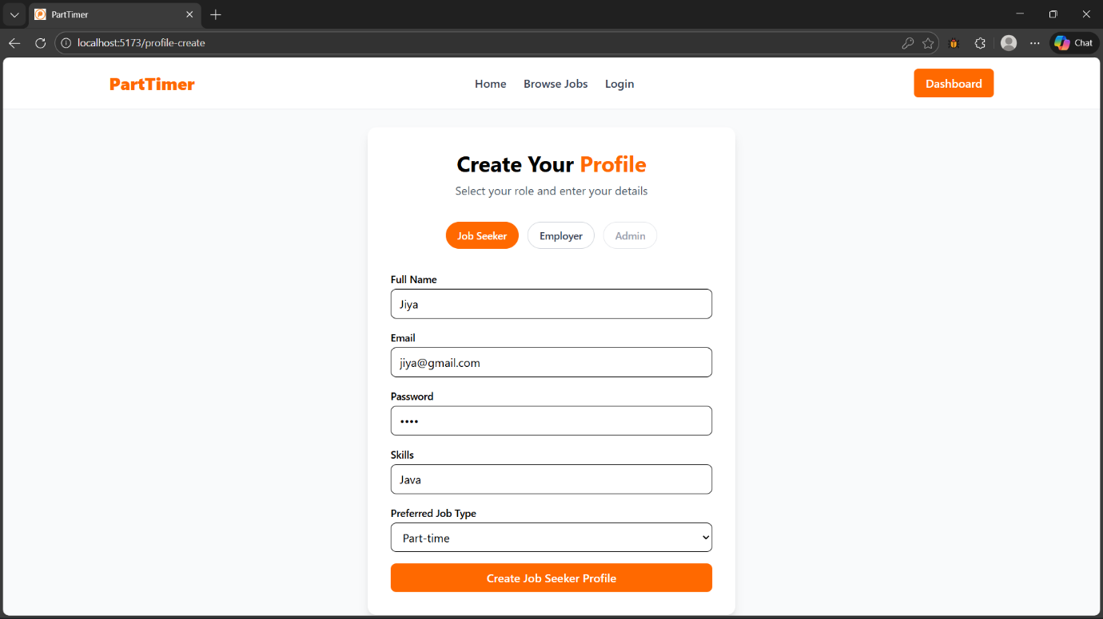

Create Profile (for login) – Employer

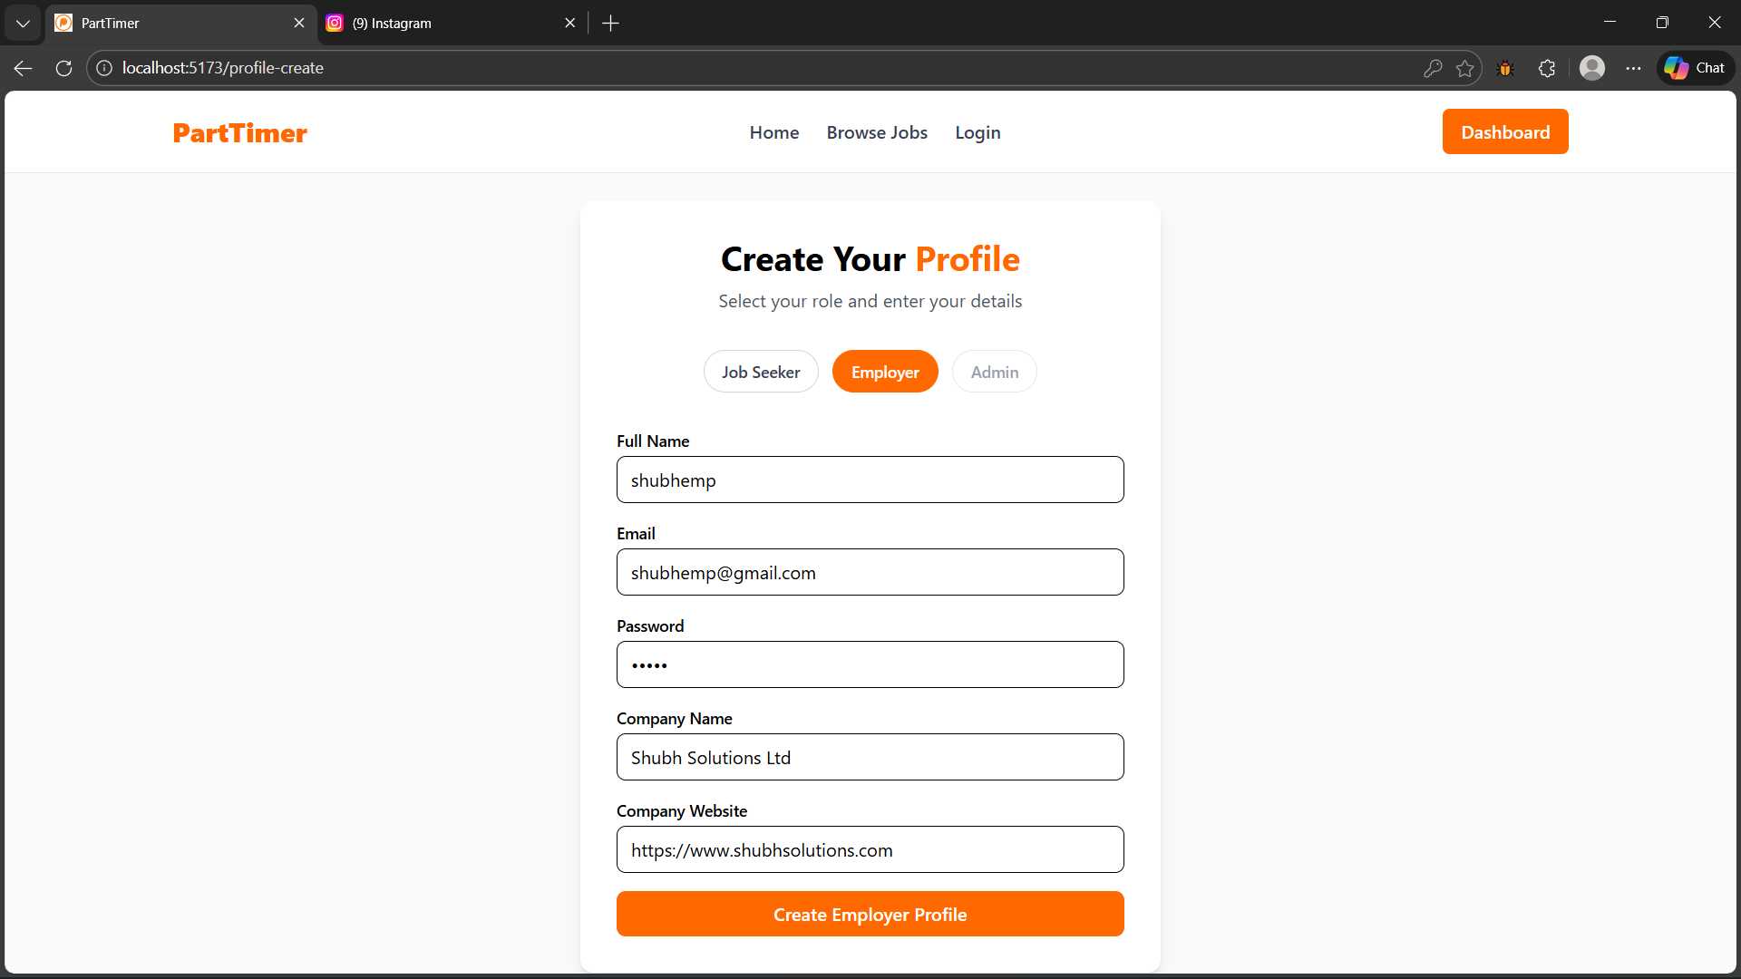

Login Job Seeker

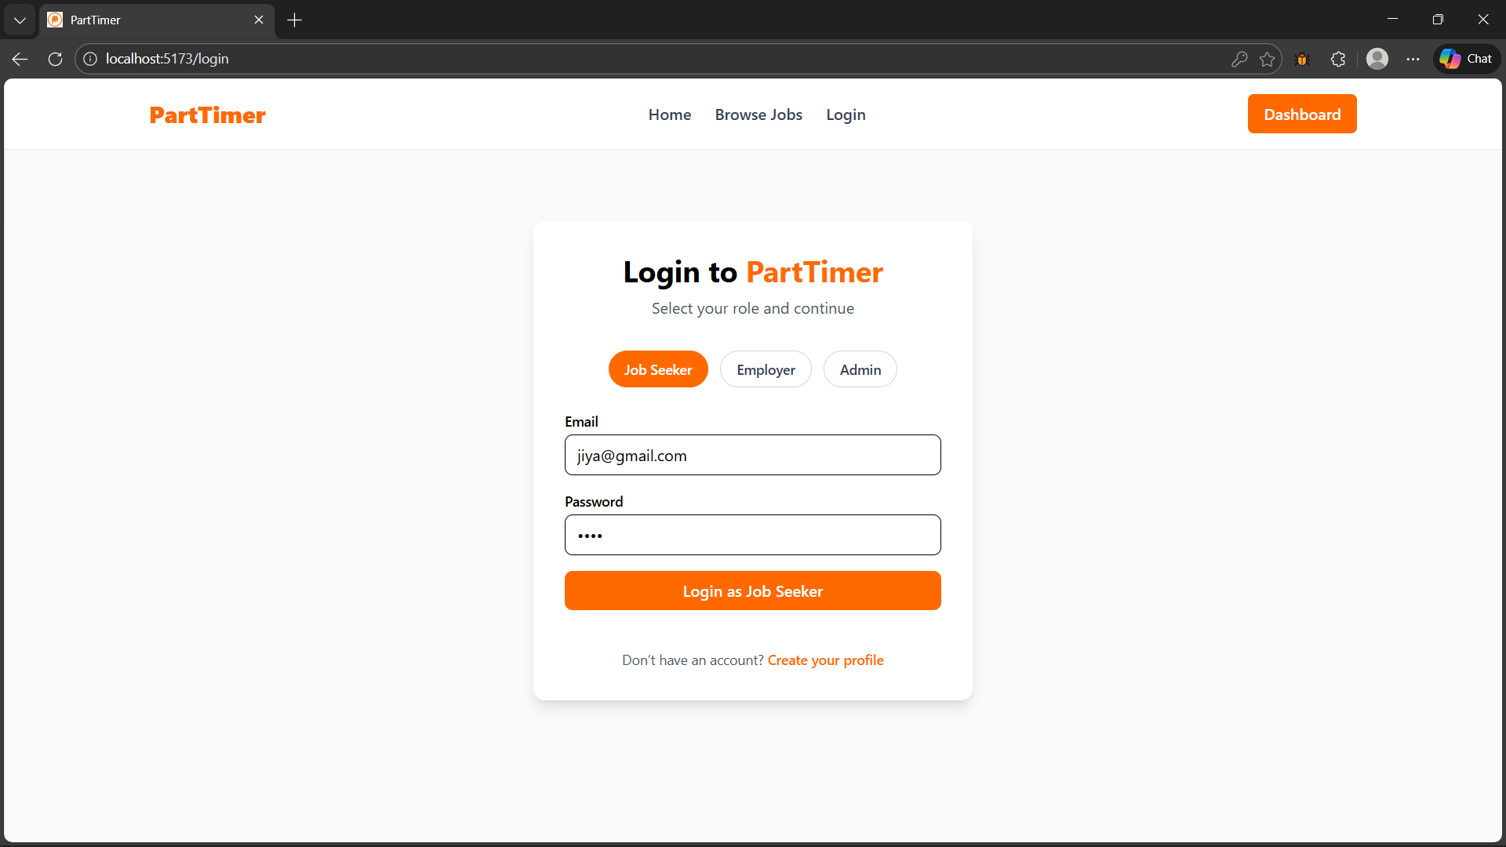

Login Employer

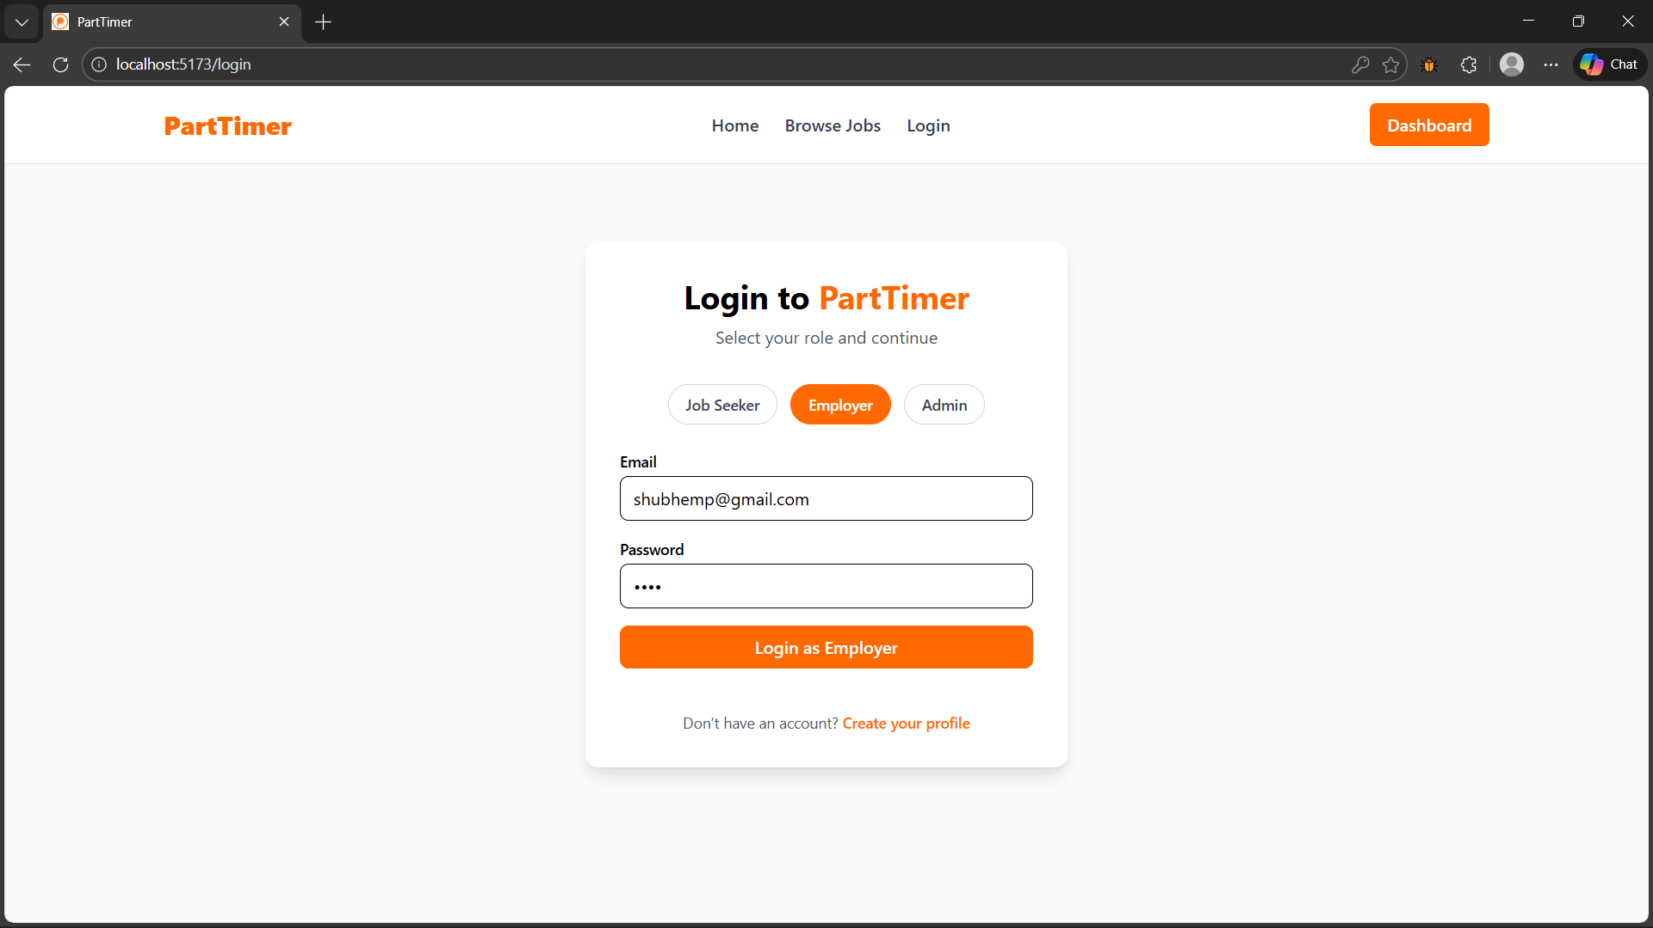

Login Admin

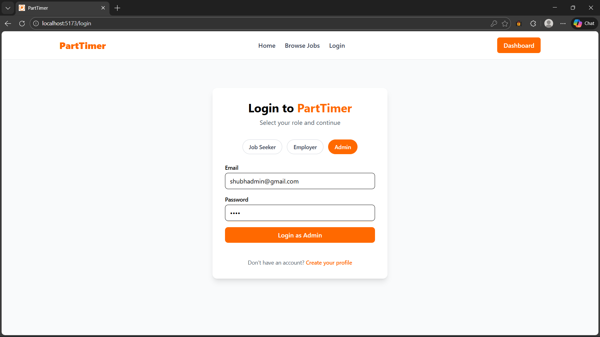

Create / Edit full Employer Profile

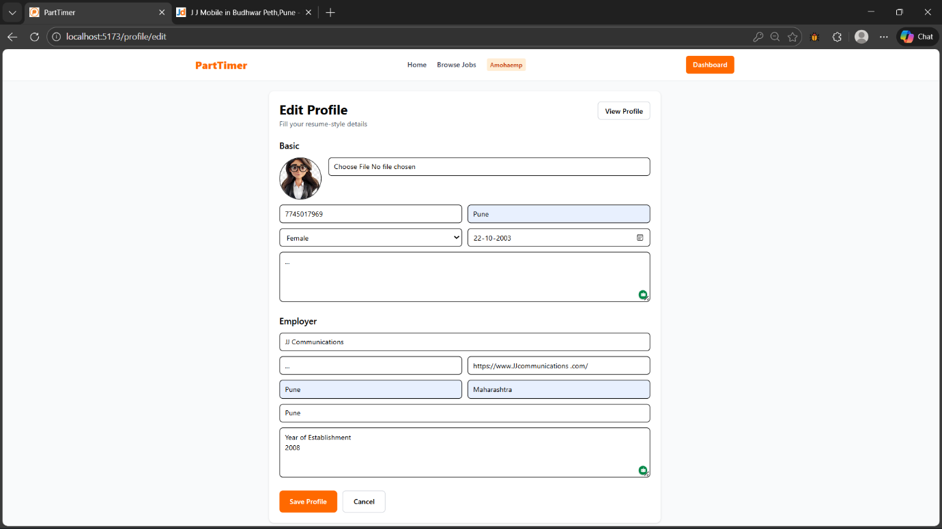

Create / Edit full Job Seeker Profile

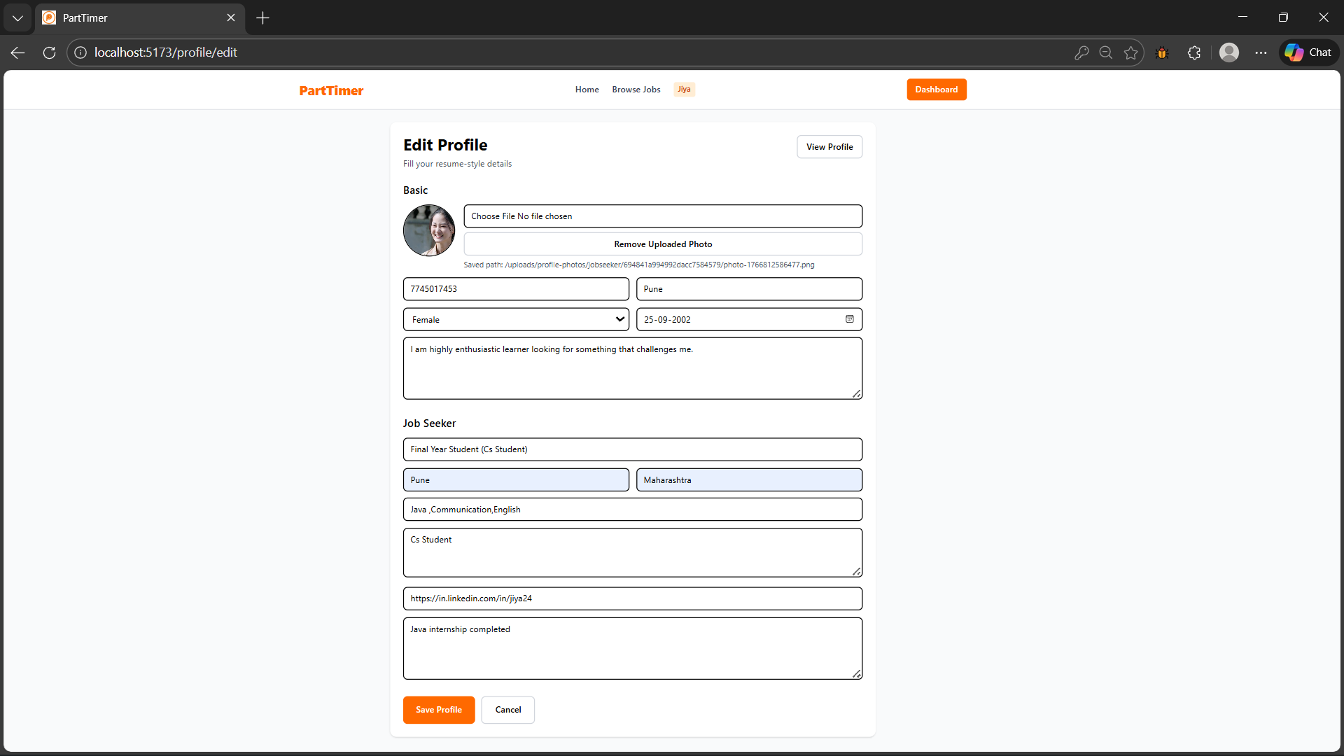

Post New Job (Employer)

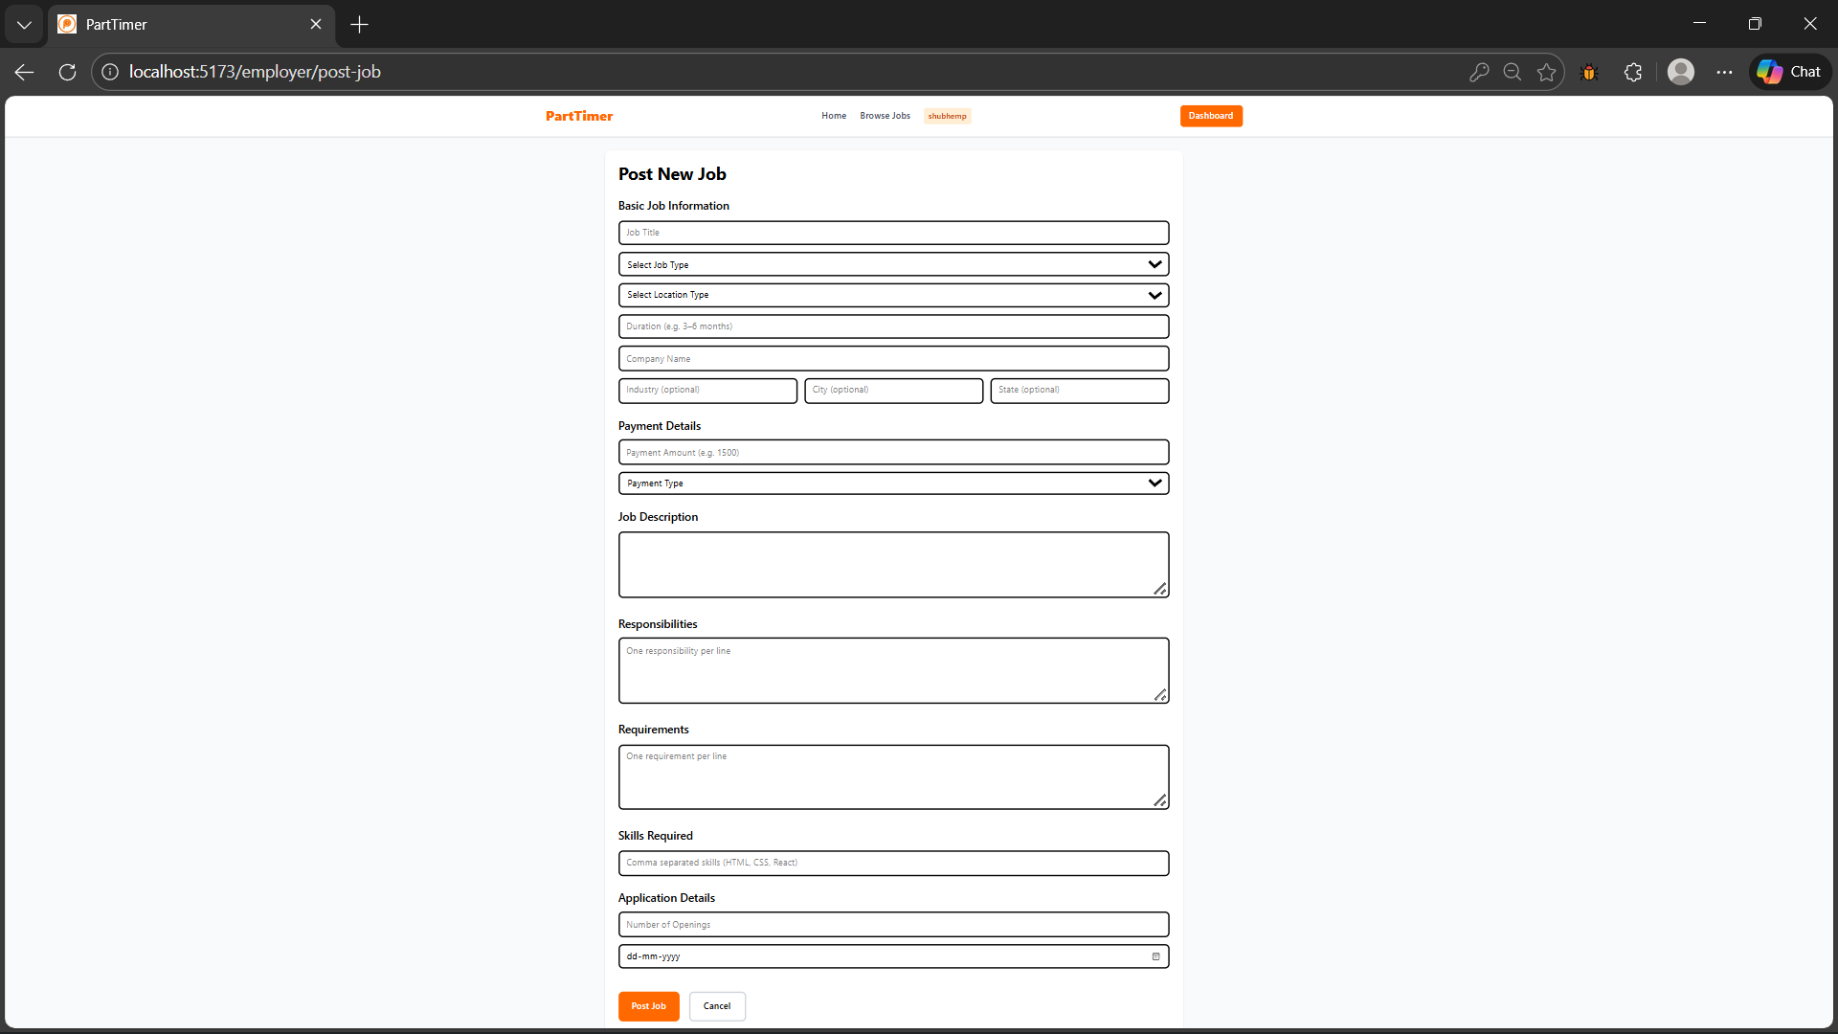

Edit Job (Employer)

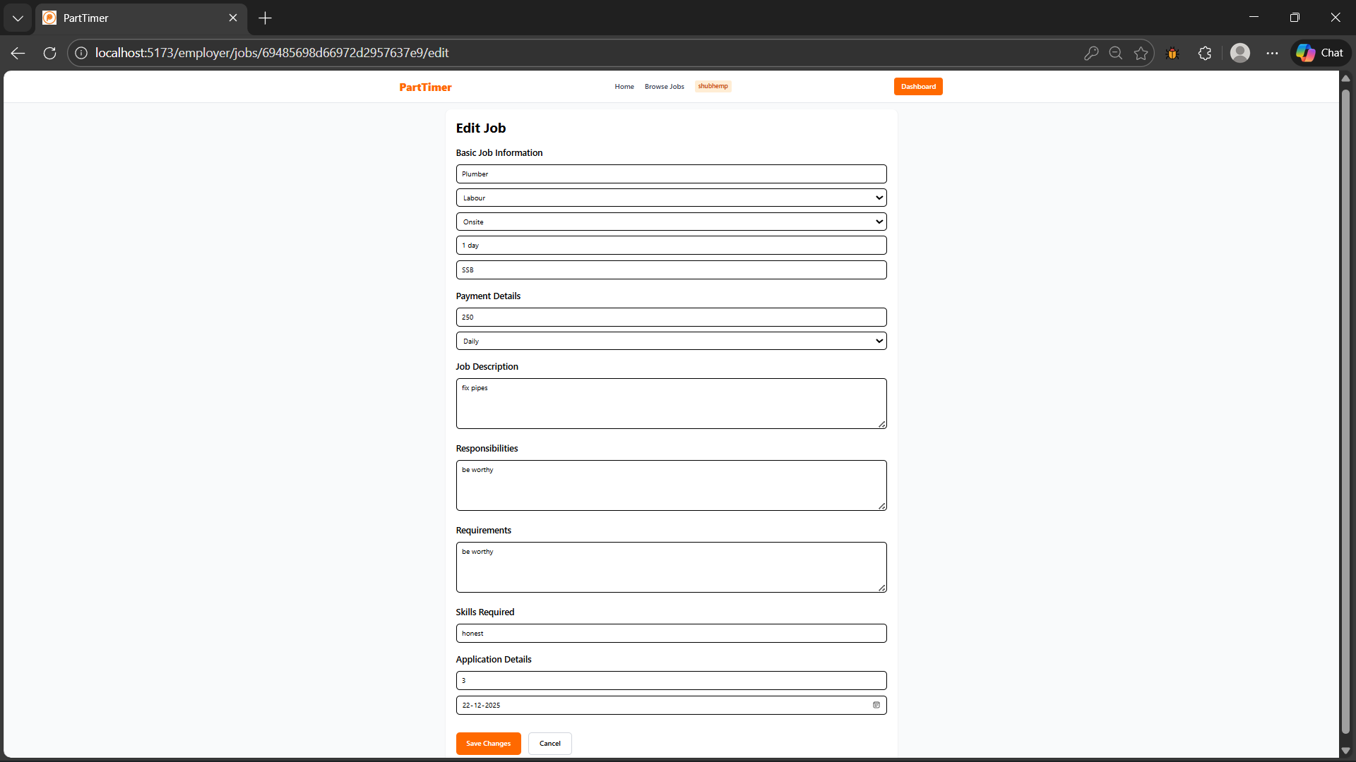

Admin Moderation Section

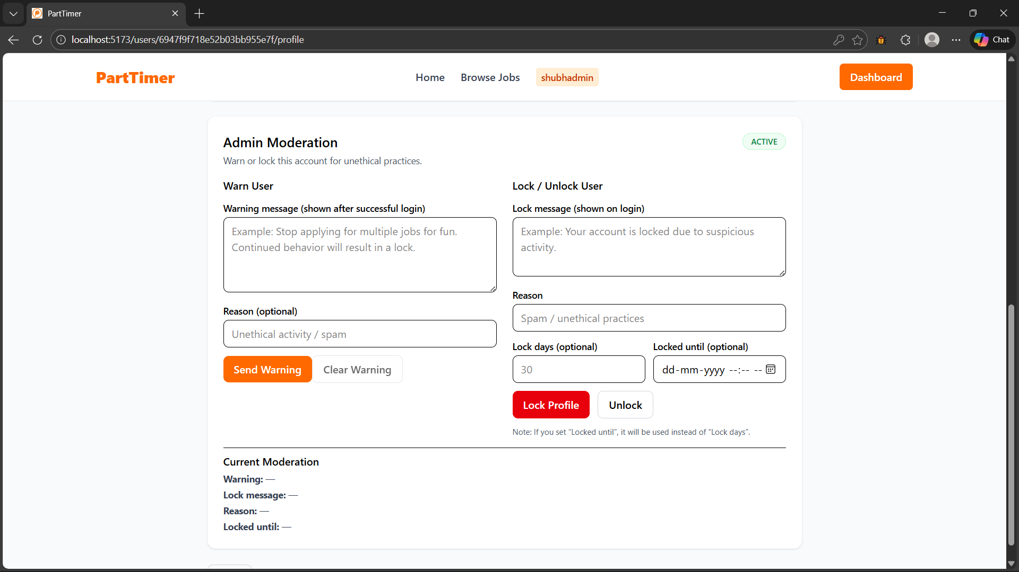

[Output Screens]

Home Page

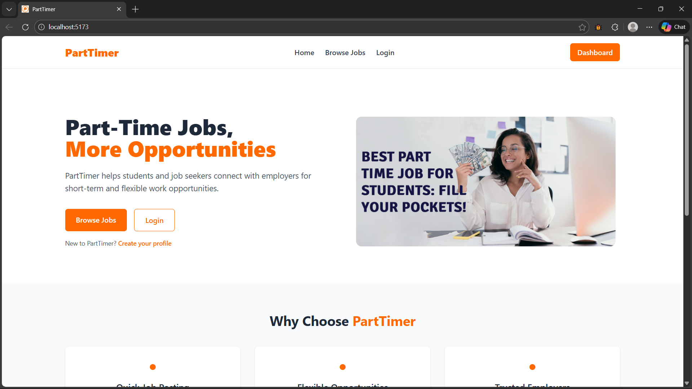

Brows Jobs

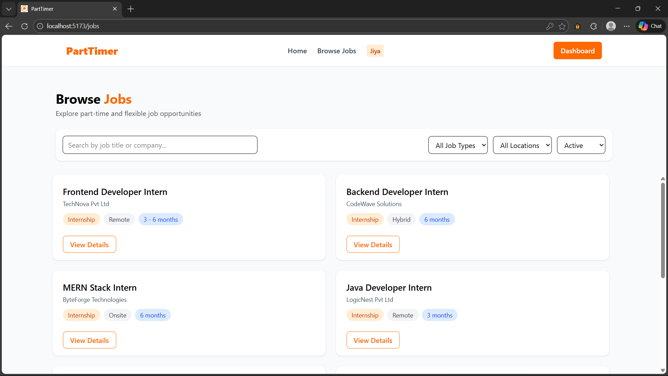

View Job Description (Job Seeker)

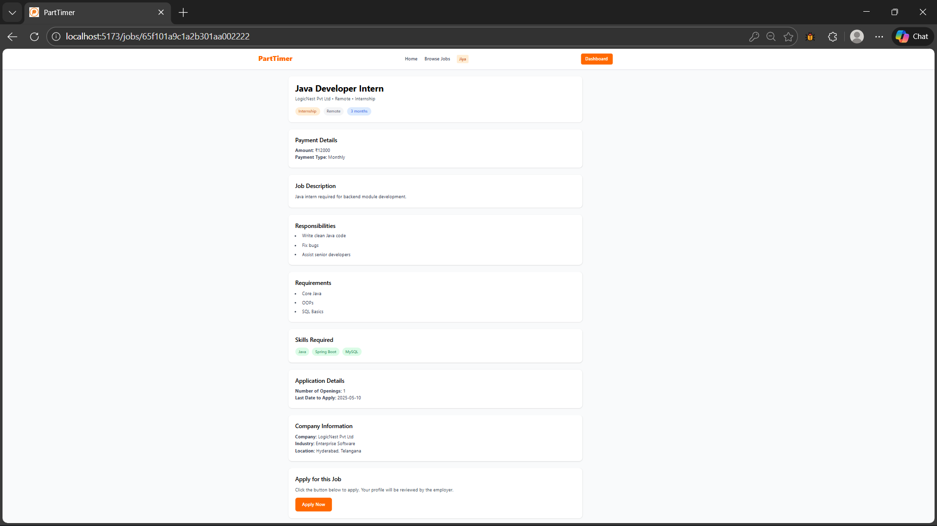

Job Seeker Dashboard

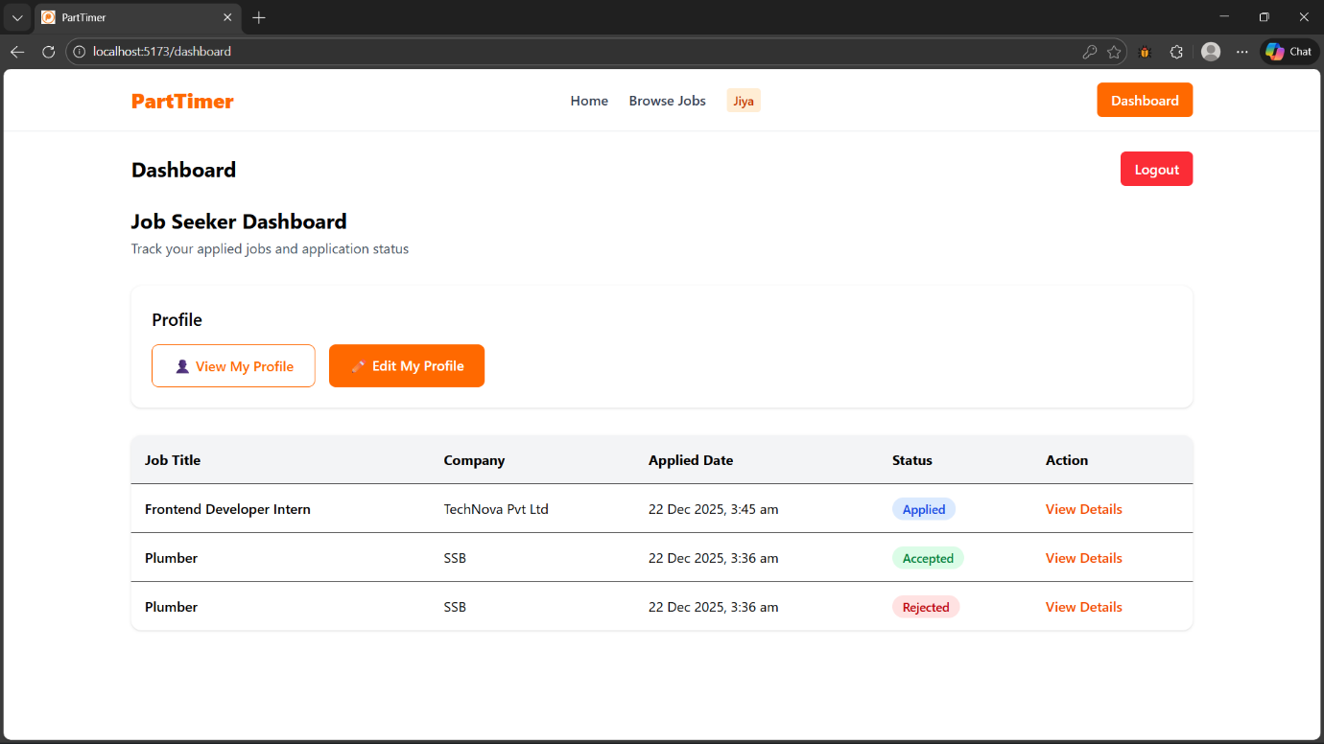

Employer Dashboard

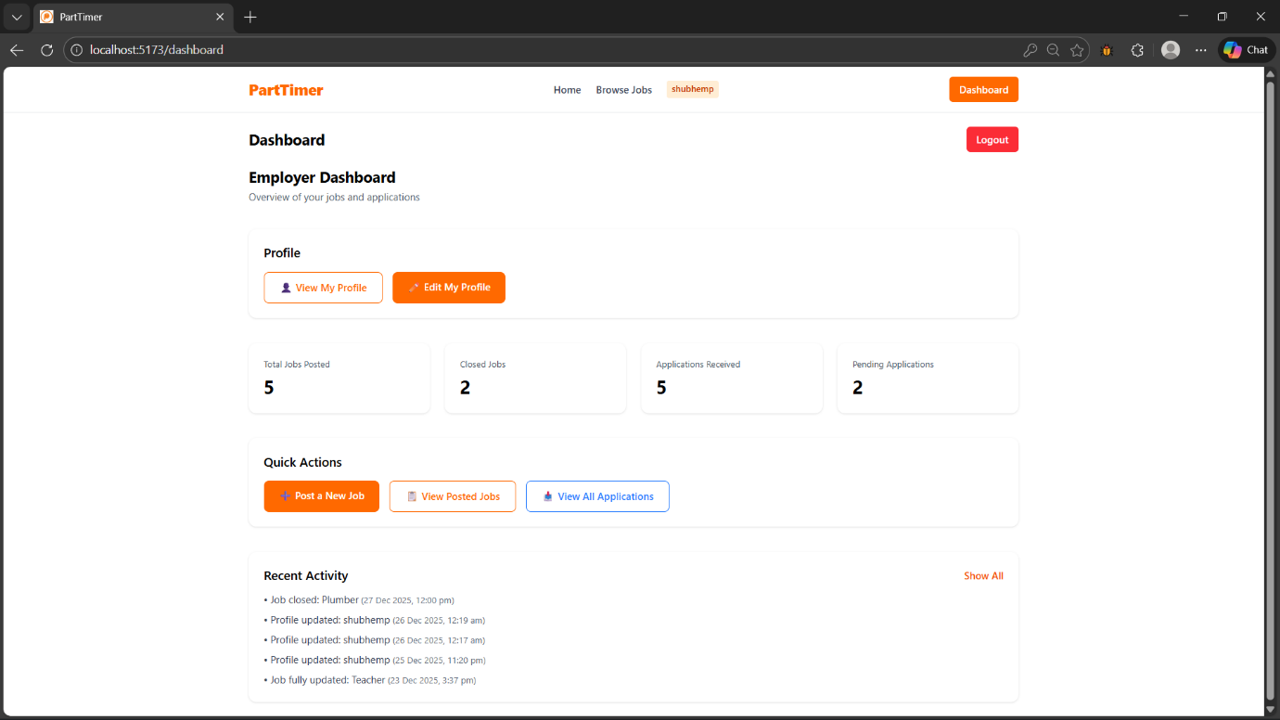

Admin Dashboard

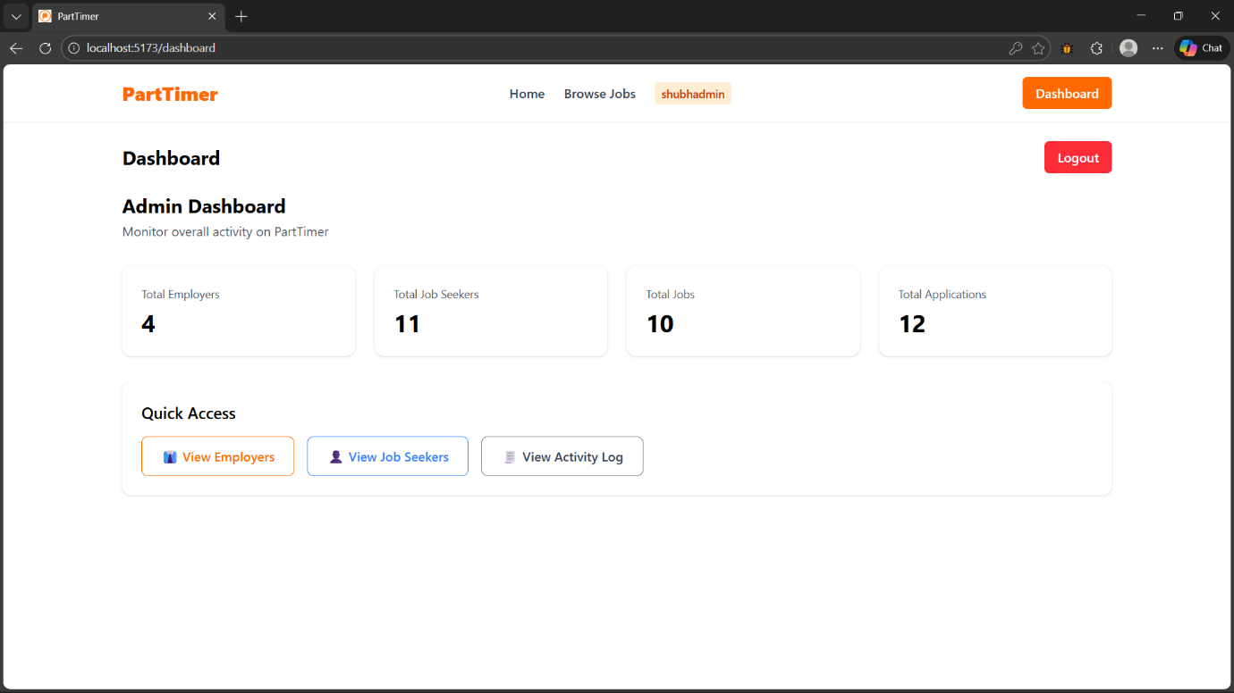

Job Seeker Profile

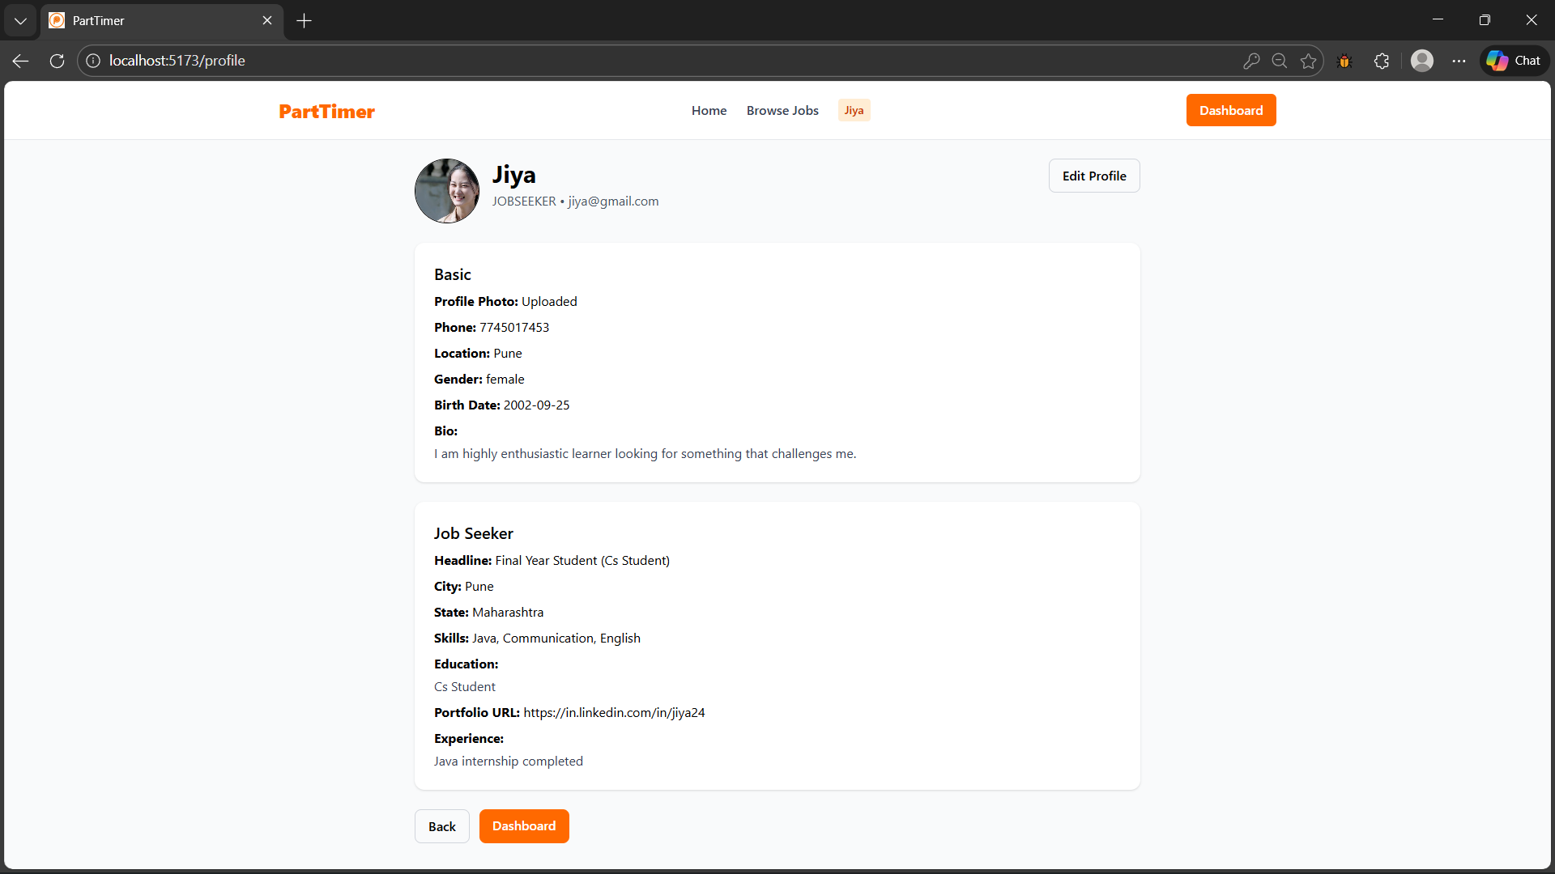

Employer Profile

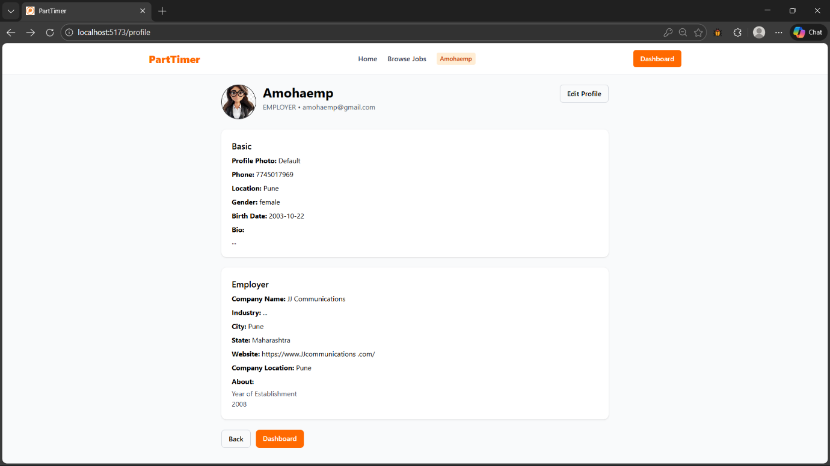

My Posted Jobs (Employers)

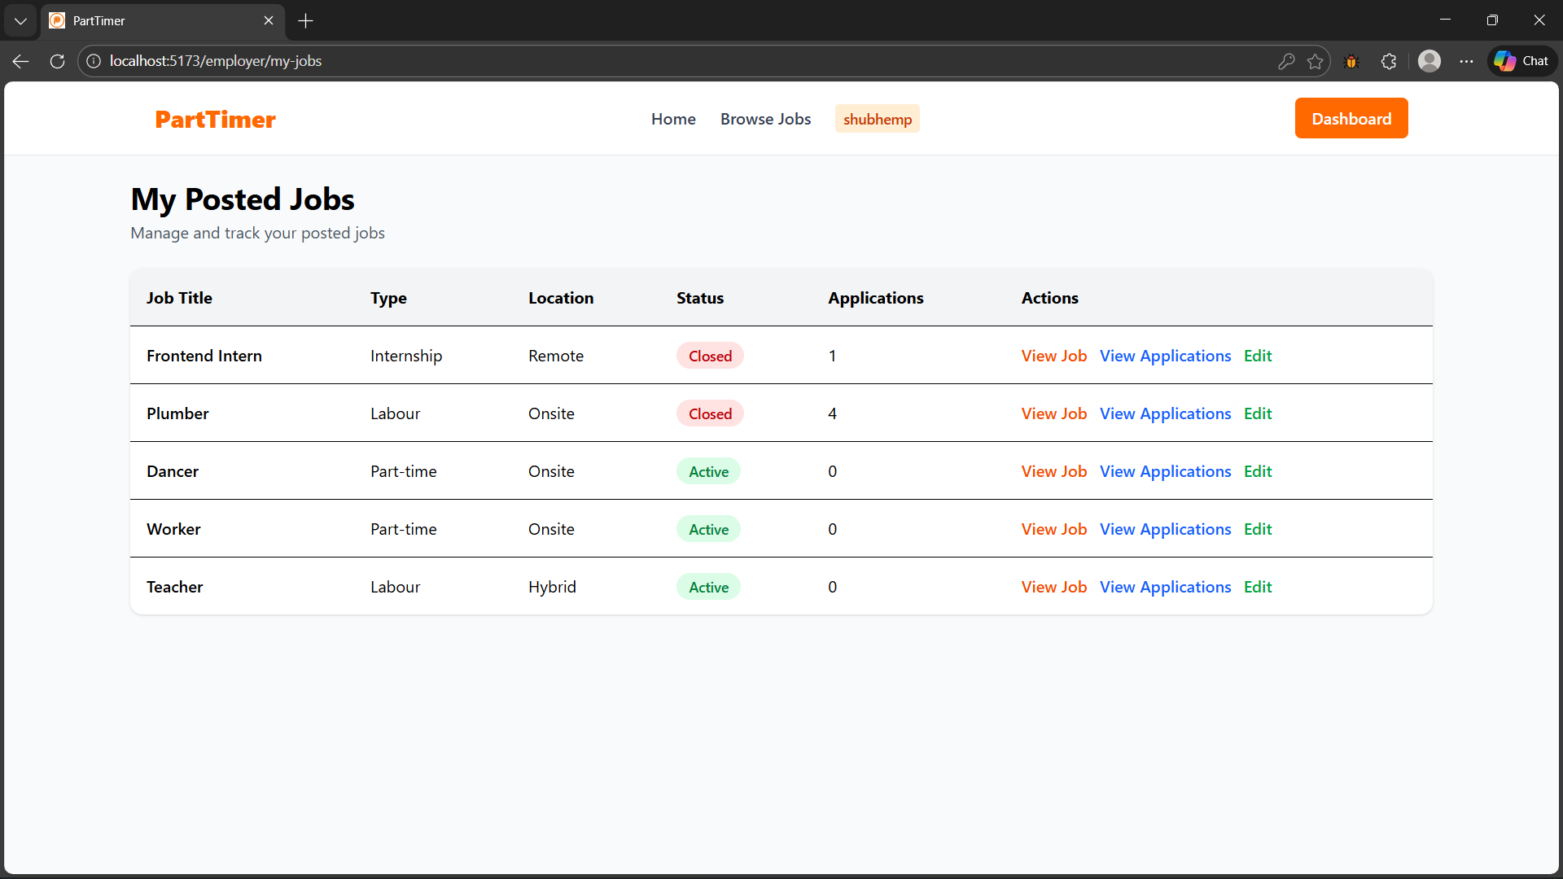

View Job (Employer)

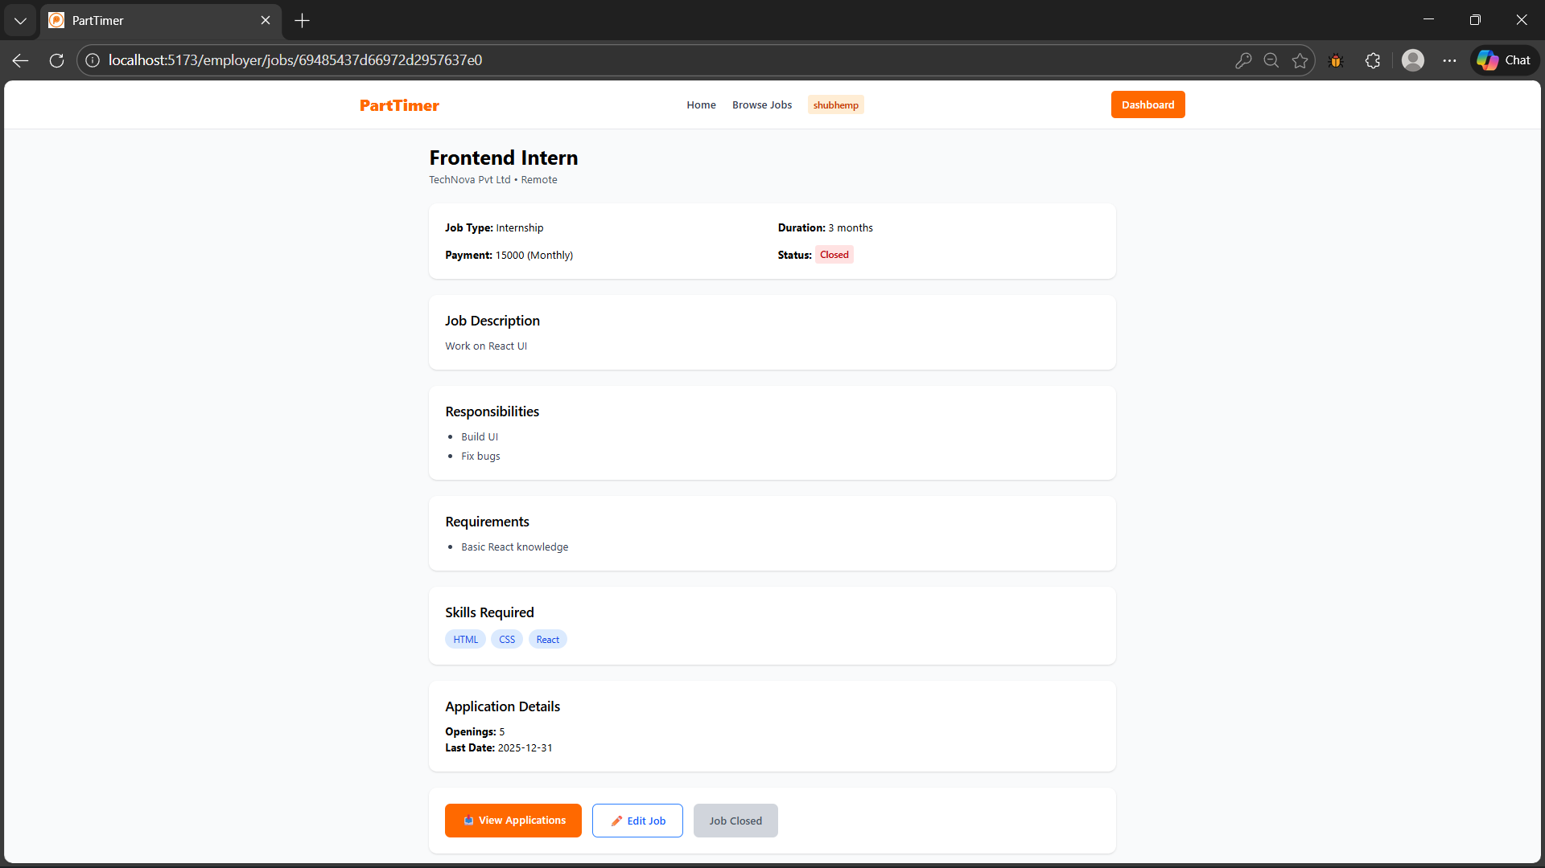

View Applications for job (Employer)

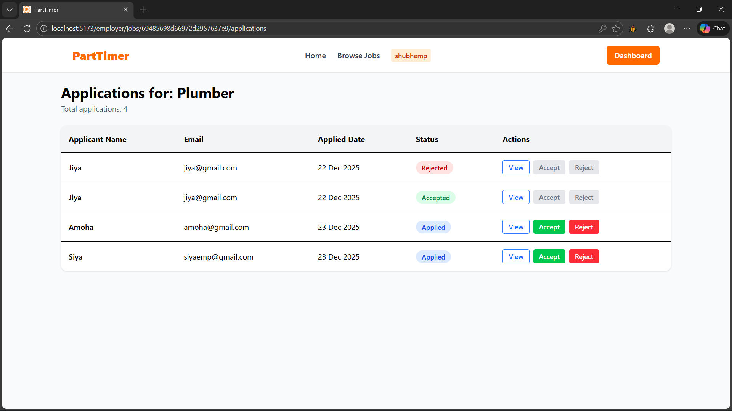

View Application For job (Employer)

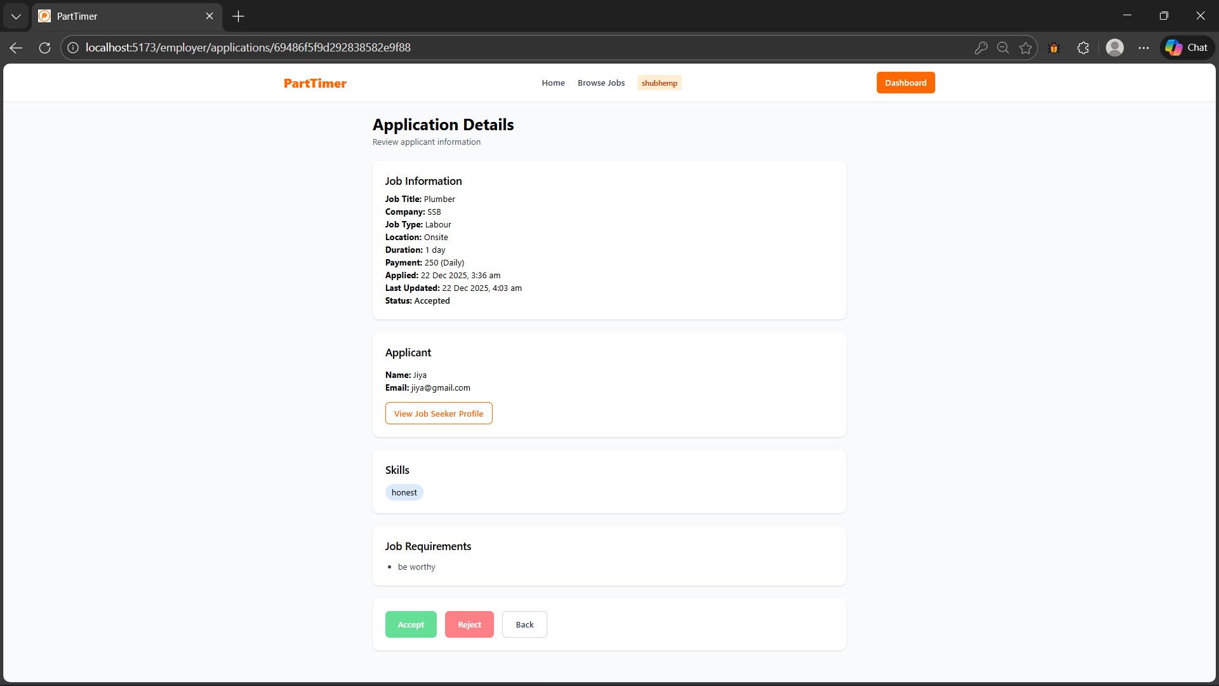

View all Job applications (Employer)

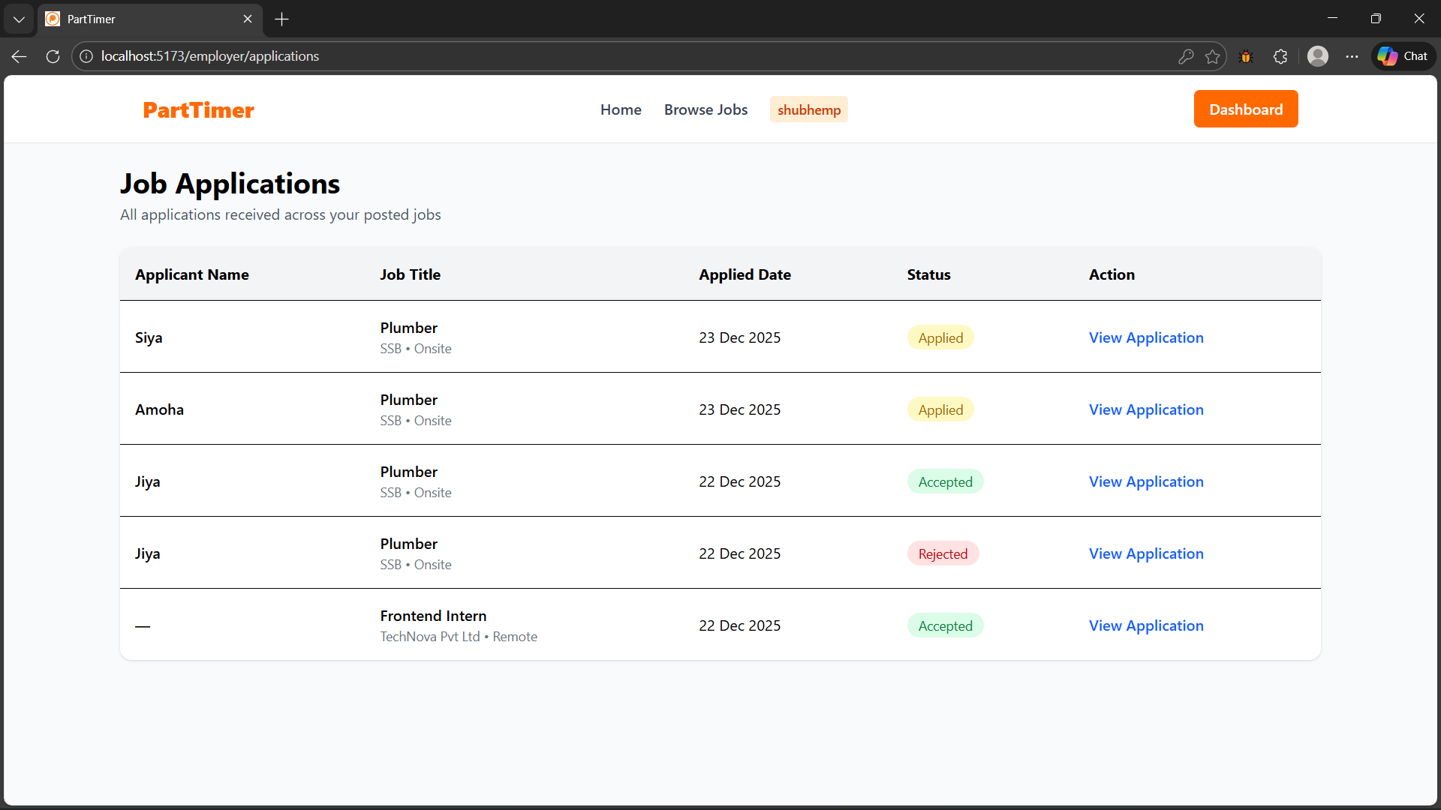

View job application (Job Seeker)

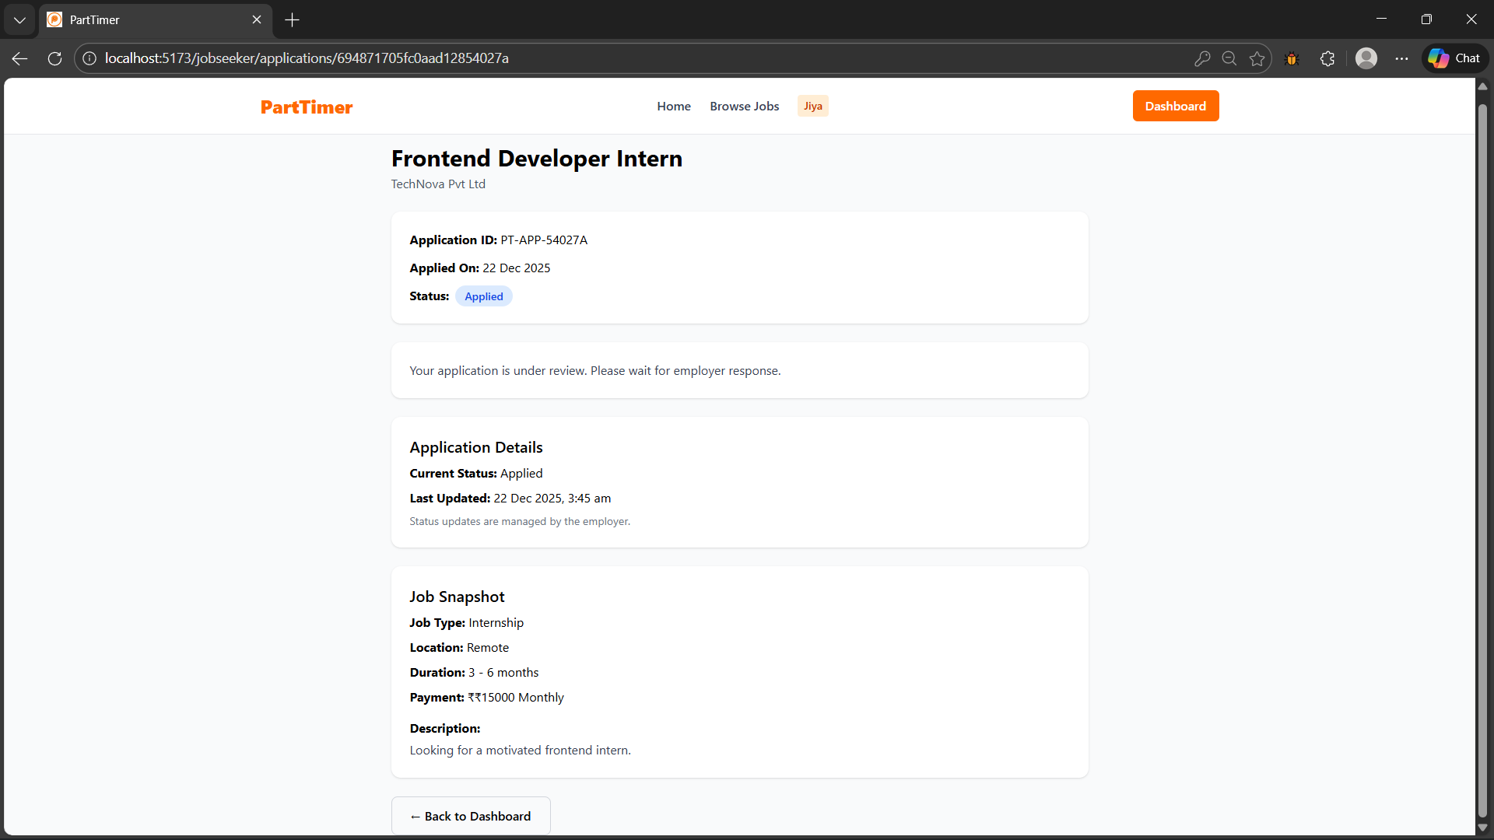

View Employer List (Admin)

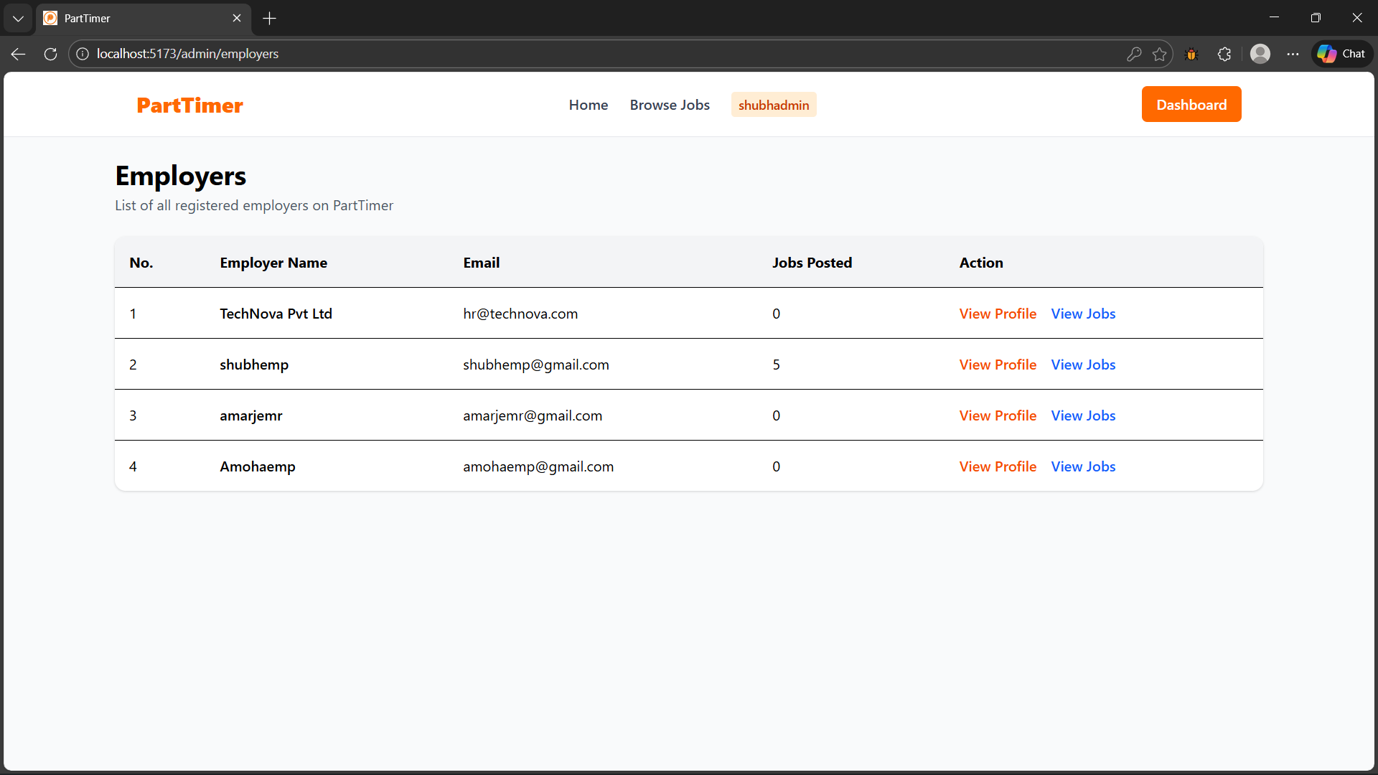

View Job Seekers List (Admin)

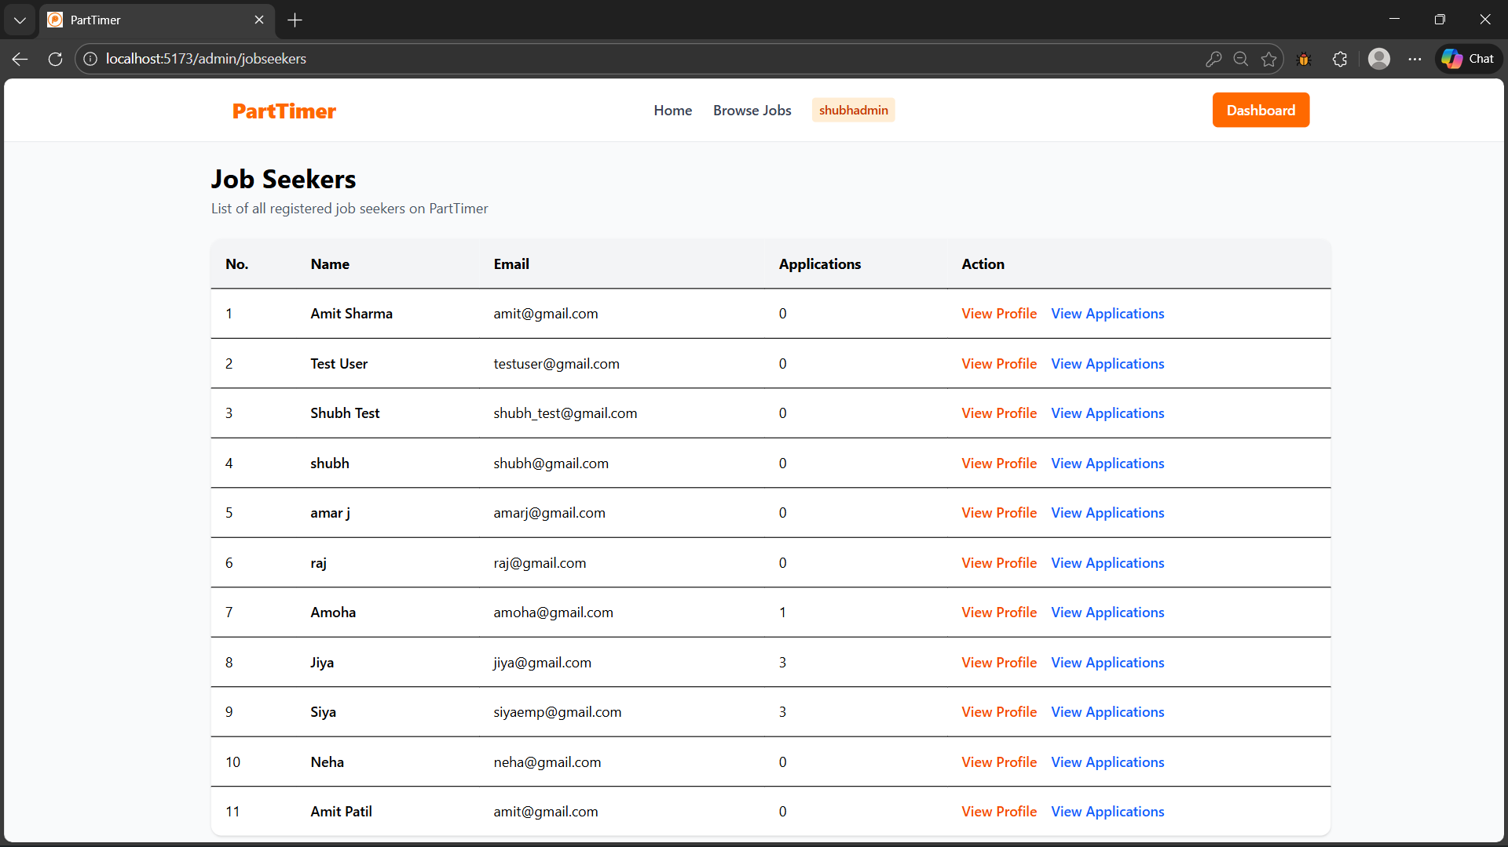

View Employer Profile (Admin)

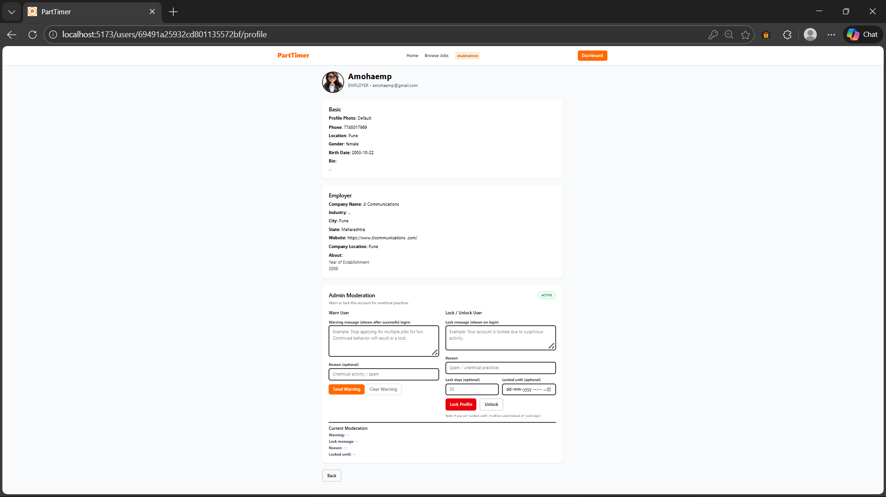

View Job Seeker Profile (Employer)

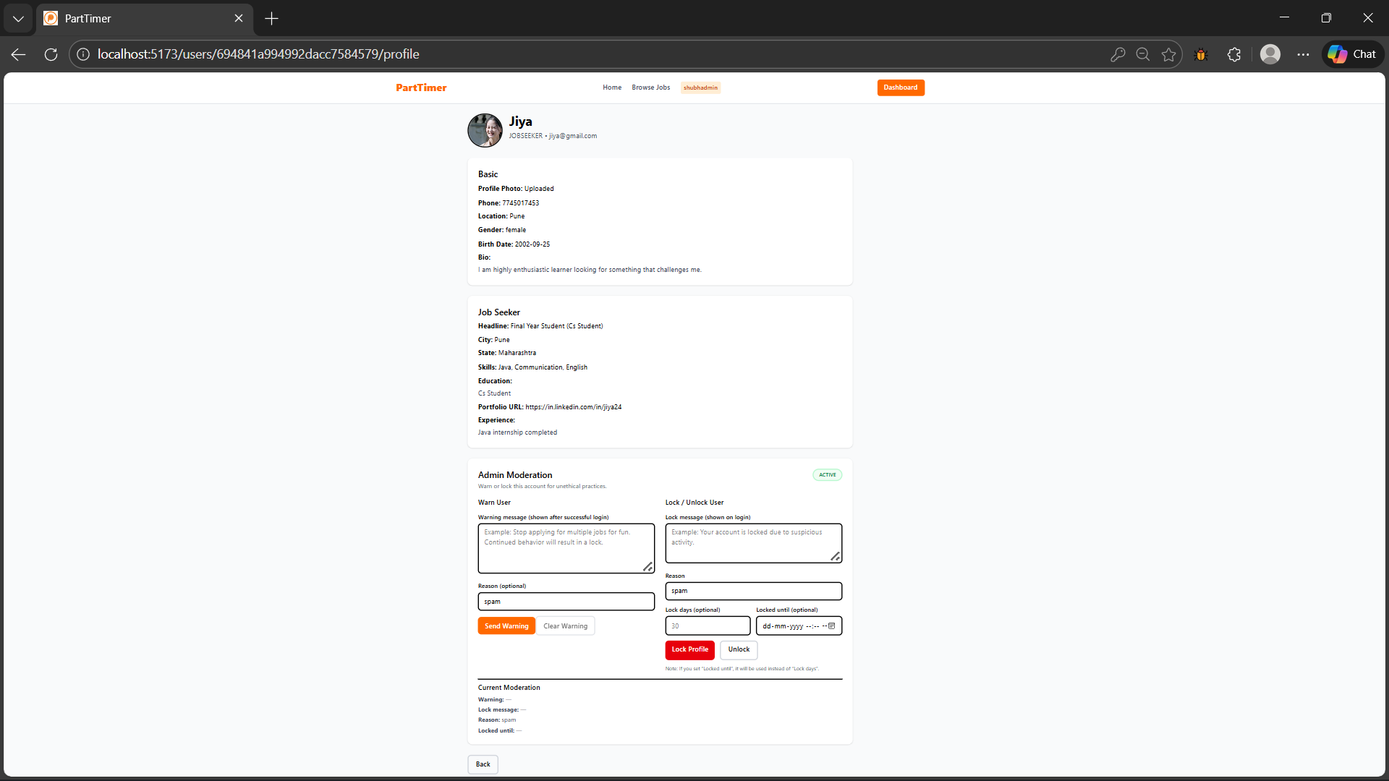

Activity Log(Admin)

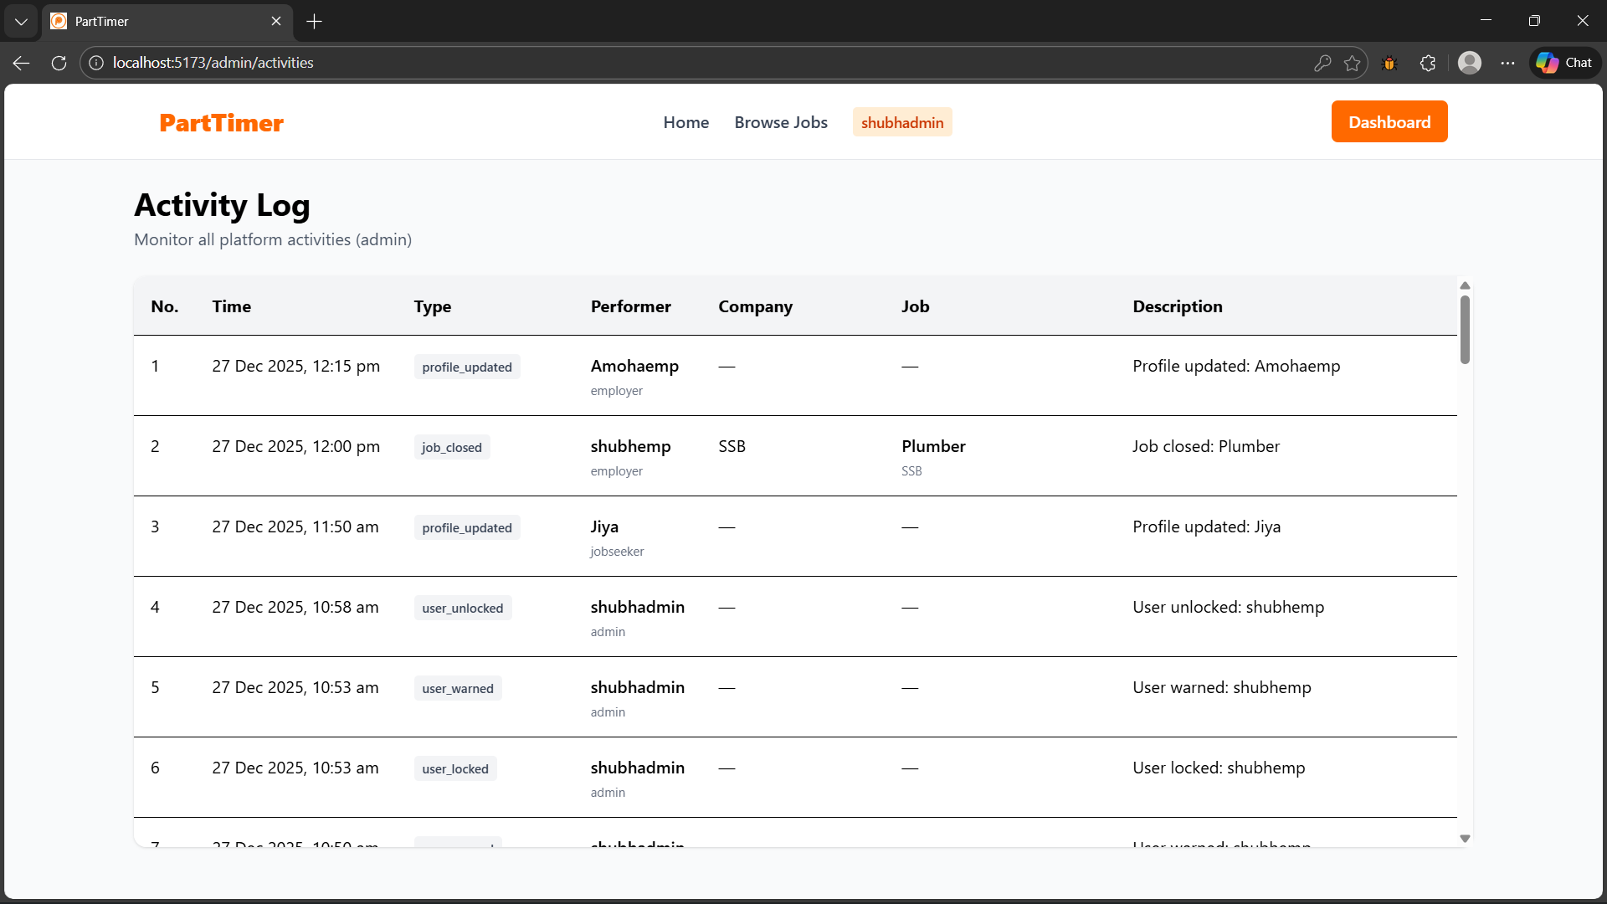

7.1 Sample User Records
- Jaya – jaya@gmail.com
- Shubhemp – shubhemp@gmail.com
- Shubhadmin – shubhadmin@gmail.com
- Shru–shru@gmail.com
- Shrau–shrau@gmail.com

3. User Manual

3. User Manual-
This section explains how different users such as job seekers, employers, and administrators interact with the system. It provides step-by-step guidance for using all major features of the application.

3.1 User Registration Process
The User Registration process allows new users to create an account on the system so that they can search and apply for jobs.
Steps:
- The user opens the website using a web browser.
- The user clicks on the Register option available on the homepage.
- A registration form is displayed on the screen.
- The user enters valid personal details such as name, email address, and password.
- The system verifies the entered information.
- After entering all required details, the user clicks on the Submit button.
- If all details are valid, the user account is created successfully and a confirmation message is displayed.
- If invalid data is entered, an error message is shown to the user.

3.2 Login Process
The Login process allows registered users to securely access the system.
Steps:
- The user enters the registered email ID.
- The user enters the corresponding password.
- The user clicks on the Login button.
- The system checks the login credentials.
- If the credentials are correct, the user is redirected to the dashboard.
- If the credentials are incorrect, an error message is displayed.

3.3 Job Application Process
This process allows users to search and apply for suitable job opportunities.
Steps:
- The user searches for a suitable job using keywords or filters.
- A list of available jobs is displayed.
- The user selects a job to view complete job details.
- After reviewing the job details, the user clicks on the Apply button.
- The job application is submitted successfully.
- A confirmation message is displayed to the user.

3.4 Employer Operations
The Employer module allows employers to manage job postings and view applications.
Functions:
- The employer logs into the employer dashboard using valid credentials.
- The employer posts new job details such as job title, description, salary, and location.
- The employer can view the list of applicants who have applied for posted jobs.
- The employer can manage job postings as required.

3.5 Admin Operations
The Admin module manages the entire system and ensures smooth operation.
Functions:
- The admin monitors registered users and employers.
- The admin manages job listings posted by employers.
- The admin removes invalid, duplicate, or inappropriate data from the system.
- The admin ensures proper system functionality and data integrity.

3.6 Validations
Validations are applied to maintain data accuracy and system security.
Validation Rules:
- Mandatory Fields Validation: Ensures that all required fields are filled before submission.
- Email Uniqueness Validation: Prevents multiple registrations using the same email ID.
- Password Length Check: Ensures that the password meets minimum length requirements.

3.7 Advantages of the System

The proposed system offers several benefits over the existing manual or semi-automated system. These advantages improve efficiency, accuracy, security, and user satisfaction.

1. Automation of Processes
- Replaces manual operations with automated workflows.
- Reduces repetitive tasks for users and administrators.
- Speeds up routine operations like data entry, validation, and reporting.

2. Improved Accuracy and Reliability
- Minimizes human errors through input validation and automated processing.
- Ensures consistent and reliable data across the system.
- Reduces discrepancies and improves trustworthiness of information.

3. Centralized Data Management
- All data is stored in a single, centralized database.
- Easy retrieval, update, and deletion of records.
- Facilitates better data organization and management.

4. Enhanced Security
- Role-based access control for Admin and Users.
- Protects sensitive data from unauthorized access.
- Ensures secure login and password protection.

5. Time and Cost Efficiency
- Reduces time spent on manual tasks.
- Minimizes paperwork and operational costs.
- Frees up human resources for more productive work.

6. User-Friendly Interface
- Intuitive and easy-to-use interface.
- Reduces the learning curve for users.
- Provides clear navigation and prompt notifications.

7. Scalability
- System can handle increasing number of users and data.
- Supports future enhancements and additional features without major modifications.

8. Easy Monitoring and Reporting
- Administrators can monitor system activities and user actions.
- Generates accurate reports for decision-making.
- Helps in analyzing trends and system performance.

9. Improved Decision Making
- Quick access to reliable data allows faster and better decisions.
- Supports both operational and strategic planning.

Conclusion
The proposed system is efficient, reliable, secure, and scalable, offering significant advantages over the existing system. It not only simplifies operations but also enhances productivity, data integrity, and overall user satisfaction.

3.8 Limitations

The proposed system is designed to address the limitations of the existing manual or semi-automated processes and provide a more efficient, reliable, and user-friendly solution. Through careful planning, requirement analysis, and systematic design, the system achieves the following key outcomes:

Key Points of Conclusion
- Efficiency and Automation
  - Routine tasks are automated, reducing human effort and saving time.
  - Streamlined processes allow users to perform tasks faster and with less effort.
- Accuracy and Reliability
  - The system ensures accurate data processing and consistent outputs.
  - Reduces errors commonly found in manual operations.
- Security and Data Integrity
  - Implements role-based access control, secure authentication, and database protection.
  - Ensures that sensitive information is stored safely and is accessible only to authorized users.
- Centralized Data Management
  - All data is managed in a centralized database, making retrieval, update, and reporting easier.
  - Facilitates better decision-making based on accurate and real-time data.
- Scalability and Future Enhancement
  - Designed to accommodate future growth in users and data.
  - Allows addition of new features without major system overhaul.
- User-Friendly Interface
  - Easy navigation and intuitive design enhance user experience.
  - Minimal training is required for users to operate the system effectively.

3.9 Future Enhancements
While the proposed system effectively meets current requirements, there are several enhancements and additional features that can be implemented in future versions to further improve functionality, usability, and scalability.

1. Mobile Application Support
- Develop mobile versions (iOS and Android) to allow users to access the system on-the-go.
- Push notifications for real-time updates and alerts.
- Improved accessibility for users without desktop access.

2. Advanced Reporting and Analytics
- Implement dashboards with visual analytics (charts, graphs, trends).
- Enable predictive analysis for better decision-making.
- Generate customizable reports based on user requirements.

3. Integration with External Systems
- Connect with third-party systems, APIs, or cloud services.
- Enable seamless data exchange and automation across platforms.
- Enhance overall system interoperability.

4. Enhanced Security Features
- Multi-factor authentication (MFA) for better security.
- Real-time intrusion detection and activity monitoring.
- Data encryption for sensitive information.

5. Artificial Intelligence & Automation
- Implement AI-based recommendations for administrative decisions.
- Automate repetitive tasks using machine learning models.
- Predict potential system issues or user needs proactively.

6. Multi-Language Support
- Add support for multiple languages to increase accessibility for diverse users.
- Helps in scaling the system for wider geographical deployment.

7. Cloud Deployment
- Deploy the system on cloud infrastructure for better scalability and availability.
- Reduces dependency on local hardware and improves accessibility.

8. Offline Mode
- Allow limited system functionality offline with automatic synchronization when internet is available.
- Ensures continuity of operations in case of network failure.

Conclusion
The proposed future enhancements aim to make the system more flexible, intelligent, secure, and user-friendly, preparing it for long-term scalability and evolving user requirements. These enhancements will increase overall system efficiency, usability, and adoption.

4. References
Proper referencing is important in a project report to acknowledge the sources used for information, frameworks, technologies, and research. Below is a professional and commonly used format for references in project reports:

Websites / Online Resources
- W3Schools, HTML, CSS, JavaScript Tutorials, https://www.w3schools.com
- Node.js Official Documentation, https://nodejs.org/en/docs/
- MongoDB Official Documentation, https://www.mongodb.com/docs/
- TutorialsPoint, Software Requirement Specification (SRS), https://www.tutorialspoint.com/software_engineering/software_requirement_specification.htm

